CSE301 Biocomputation, 2016
Week 8 Tutorial Exercises on RBF

- Assume we have an RBF network with the following functions in the hidden layer:
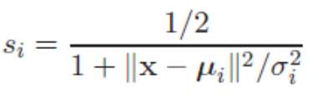
Assume a linear activation function in the output layer. The network should be trained in the same way as in the back-propagation exercise, i.e. off-line (batch) with a mean square error measure. The desired output is as usual in a variable d.
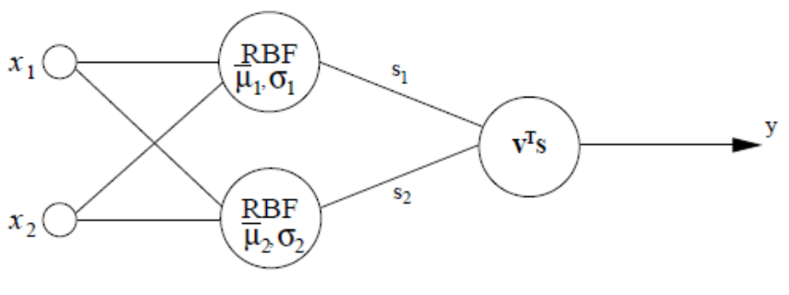
a) First, assume that the RBF units have a constant size, i.e. that σ₁=σ₂ = σ, where σ is constant. Give the update rule for the RBF-layer (i.e. determine how the parameter vecors μi should be updated).
b) Now, also the size of the RBF units should be adapted. Give an update rule for
the RBF layer when also the _i-parameter should be updated.

Answer:
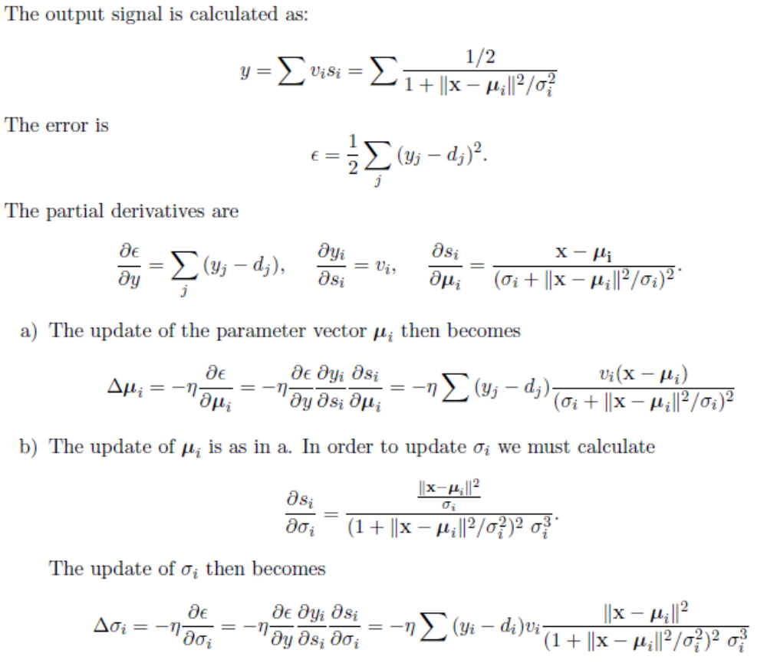

- The following RBF network uses Gaussian activation functions in the hidden layer and linear activation function in the output layer. Suppose the Gaussians are centered at [0, 0] (neuron 1) and [3, 3] (neuron 2) and have variances of 1 and 1.5, respectively Given the weight vector w = [2, 1, 2]^{T}, compute the output y when an input x = [1, 1]^{T} is applied to the network.
1
2
x₁
x₂
1
w₀
w₂
w₁
y

- Given the 3 input-output samples {d_{i}, x_{i}} (i = 1, 2, 3): {5, (0, 2)}, {8, (1, 3)}, and {12, (2, 4)}, compute the interpolation matrix  when the Gaussian radial-basis functions with variances of 1 are used.

- Refer to question 3 above. Suppose we want to fit a curve through the first 2 input-output samples only (i = 1, 2). Solve the resulting strict interpolation problem to find the interpolation weights. Draw the network that solves this interpolation problem showing all nodes and links with activation functions and weights.

- Consider a regularization network with 10 input nodes, 125 hidden neurons, and 2 output neurons (no bias inputs). What is the number of free parameters in the network? Explain your answer clearly.

- Two equations used in the context of Radial Basis Function (RBF) mappings are:

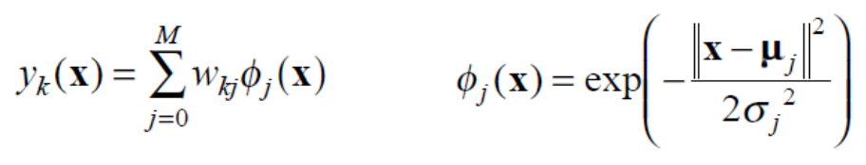
(a) Explain what each of the symbols in them mean, and what it is that is being computed by them.
(b) Show how the RBF mapping can be represented in the form of a network.
(b) How does one train such a network?
(d) What factors will affect our choice of the number of hidden nodes we use in such a network?

- A company has collected a large amount of data in the form of pairs of input and output vectors, and wants you to build a system that will predict the outputs for new inputs.
(a) Design an appropriate Radial Basis Function (RBF) network for them.
(b) Explain what will be computed at each network layer; Explain how you will determine the input to hidden layer weights/parameters.
(c) Explain how you will determine the hidden to output layer weights/parameters.
(d) What is the main advantage your Radial Basis Function (RBF) network will have over a Multi-Layer Perceptron (MLP) network carrying out the same function?

